12.6.1_UNCTAD_UNEP_14.02.2020

***Medium sized storyline***

**Goal 12-Indicator 12.6.1: Number of companies publishing sustainability reports**

**Businesses striving to close large gaps in sustainability reporting**

The 2030 Agenda increased sustainability reporting among businesses and led to a closer engagement of the key stakeholders such as international organizations, standard setters and businesses that facilitated launch of a number of initiatives on developing a commonly agreed and harmonized set of indicators for consistent and comparable reporting on environmental, social and governance as well as the SDG related matters. However, there are still large disparities across countries and regions as it has been revealed by the study conducted with support of the AI technology based on the UN Global Compact database that contains data on over 10,000 companies of different sizes based in over 160 countries. Reports for consistence and comparability were screened based on the minimum requirements for metadata guidance SDG 12.6.1 aligned with the UNCTAD *Guidance on core indicators for entity reporting on contribution towards implementation of the Sustainable Development Goals”[1]*.

Significant divergence has been identified in all four themes of sustainability reporting of the metadata guidance on the SDG 12.6.1[2]: economic, environmental, social and institutional. Though elements included in the report in most cases are supported by quantitative indicators, some critical aspects in environmental, social and governance domains, were hardly reported, including such as use of water, waste and emissions, gender equality, training on anti-corruption issues, the expenditure on employee health and safety among others.

In certain regions, such as Eastern Asia, Europe, Latin America and the Caribbean as well as Northern America, firms demonstrate a higher level or reporting of the baseline data as minimum requirements for reporting on the SDG indicator 12.6.1 *“Number of companies publishing sustainability reports”* Large gaps in reporting of some regions are evident, especially in Africa, Central Asia and the Oceania.

The coming years will be important to advance the progress in the area and identify whether sustainability reporting will be used by an increasing number of firms to demonstrate commitment to sustainable development in attaining the 2030 Agenda.

**Chart 1: Screening on the Minimum Requirements for Metadata Guidance SDG 12.6.1 (Percentage)**

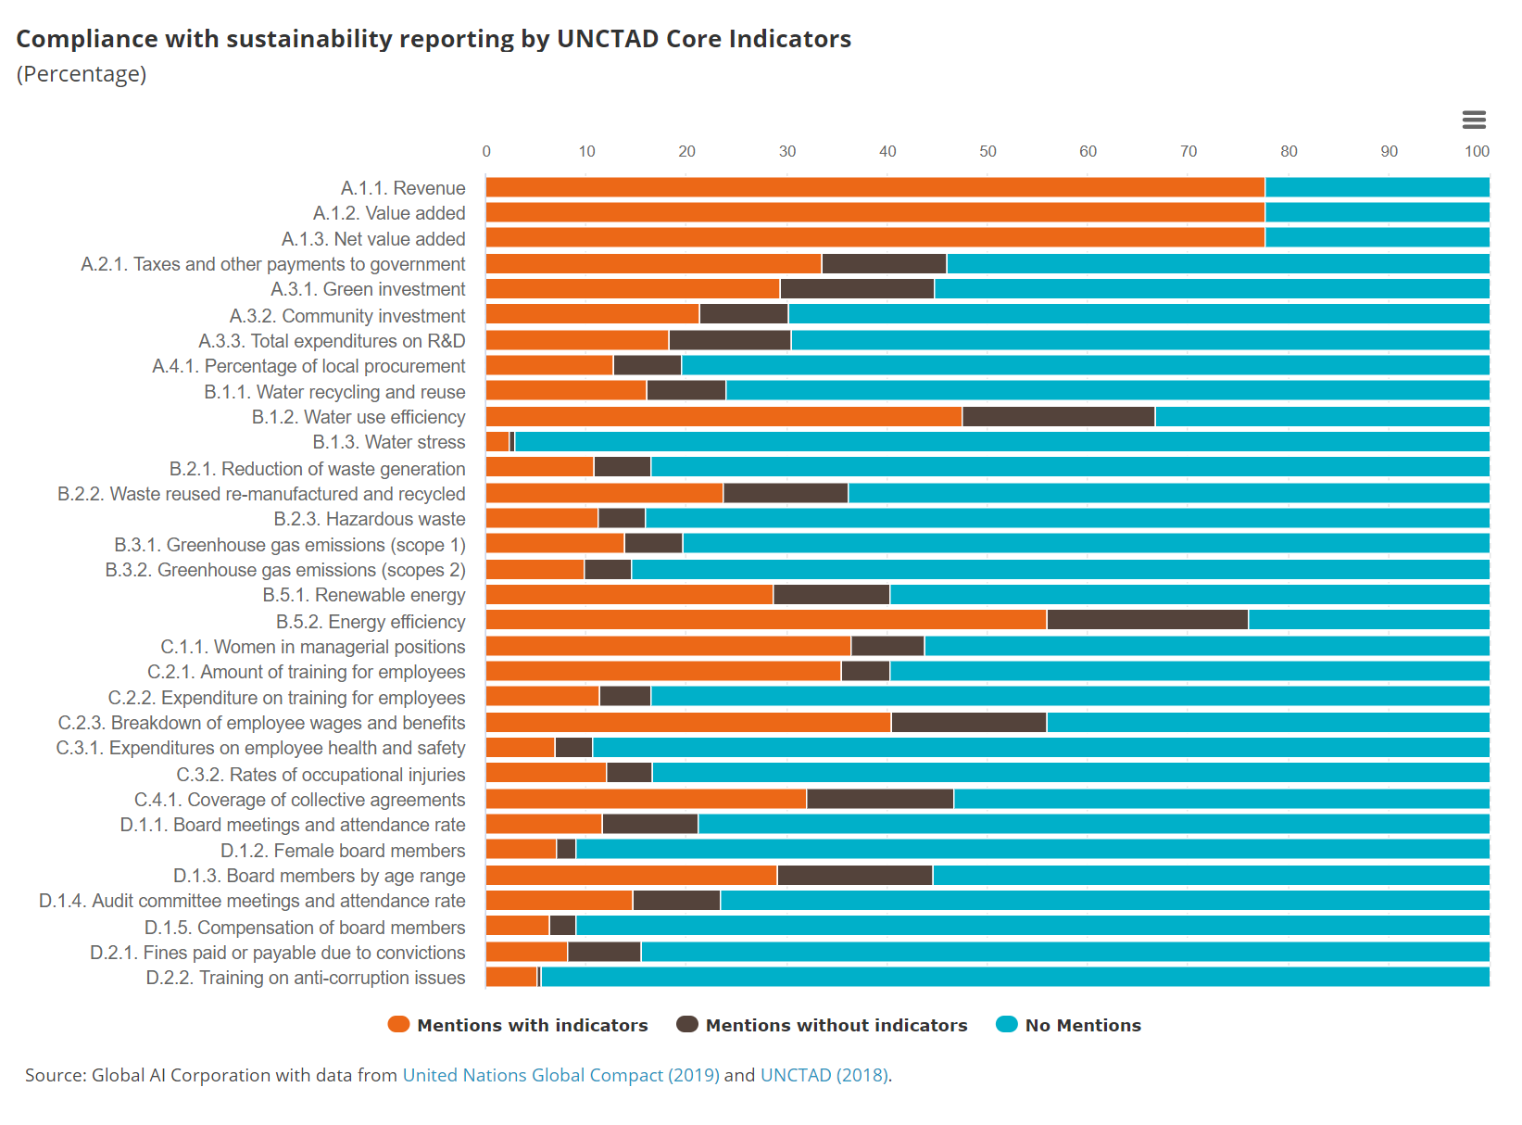

Source: Global AI Corporation based on data of United Nations Global Compact (2019)

**Chart 2: Screening on the Minimum Requirements for Metadata Guidance SDG 12.6.1: Regional average (Percentage)**



Source: Global AI Corporation based on data of United Nations Global Compact (2019)

1. <https://unctad.org/en/pages/PublicationWebflyer.aspx?publicationid=2469>
2. <https://unstats.un.org/sdgs/metadata/files/Metadata-12-06-01.pdf>